Positive Experiences of Competition – Girls Cricket Case Study
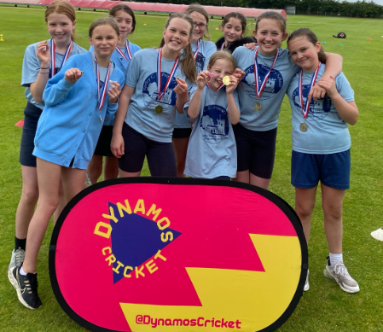
Identifying those most in need
The process of identifying the Year 6 girls as group in need began a long time ago. As the Year 5/6 teacher and PE lead in our school I am in a very fortunate position to be able to identify the groups of children who can really benefit from sport in general and competition. I have been the Year 5/6 teacher at Norley CE Primary for 4 years now and previously I was the Year 1/2 teacher for 6 years. Having taught the Year 6 girls in Year 1 and 2 I knew that it was group with certain challenges towards accessing sport outside of school even back then. Having kept a close eye on the year group I knew that when I was given the position of Year 5/6 teacher and then PE lead I could begin to make more a difference to the offer that the Year 6 girls were getting in sport and competition.
Identify a positive experience
When the girls came into my class as Year 5’s I began to put plans in place to encourage them to begin to participate in more sports in and outside of school to bring the group of girls closer together. When they were in Year 4 they had many friendship issues that with a relatively small group of 10 can lead to splits in the group. Knowing that not many of the girls were keen on football, rugby or swimming and that few of them were taking up our offer of after-school sports clubs in some these areas I asked the then Year 6 children what sports they were currently enjoying outside of school. Cricket came up again and again. Many of the then Year 6 children had recently taken up cricket and joined local clubs at Oakmere and Little Budworth (Oulton). After consultation with the head we decided to buy in some cricket coaching from Cheshire Cricket. The success of this was almost immediate.
Personal, Emotional and Social Development
Through the Cheshire Cricket PE sessions, the girls (then in Year 5) started to grow personally as a group, emotionally through greater levels of resilience and socially. Cheshire Cricket then began to undertake an afterschool Cricket session once a week for us which most of the girls took up. From here some of the girls then joined their local cricket team and strong social bonds began to grow through the game. Before this some of the girls had lacked confidence and been frustrated with certain situations which led to break ups in friendships. Through the cricket they began to come together as a whole group, setting differences aside to work together in their cricket sessions which has now led to strong friendships.
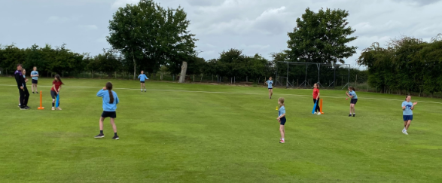
Common experience to Competition experience
The girls now had a common experience which they enjoyed participating in together. Not just in school but for many of them out of school as well. They were getting ready for being competitive. Through the Cheshire Cricket PE sessions and the afterschool sessions the girls were growing in confidence and competence. They were being given the support that they needed to begin to become competitive. This was happening in each session as they were being introduced to competitive game situations.
Intra School and Club Competitions
Through communicating and consulting with the girls it was decided that we would just hold intra school competitions initially rather than entering them into the FAVSP Cluster girls cricket competitions. This worked out well, as with Covid having a huge impact, many of the Cluster competitions were postponed or cancelled. The intra school format also allowed the girls to learn how competitions worked in an environment that they were familiar with staff that they had built relationships with. Many of the girls were also taking part in intra competitions at their cricket clubs which further enhanced their personal, social and emotional development. The enhancement of these areas of development was becoming much more evident in the girls in their day to day attitudes in school and how they were behaving towards each other.
Recruitment
The recruitment of the girls for the intra cricket competitions was done based on their interest, uptake in the afterschool club and demonstration of their positive behaviours towards the sport in school. Fortunately, all of the Year 6 girls (then Year 5) fell into each of the categories which in effect made the recruitment process one of targeted recruitment. I knew that I wanted them all to take part but they had also earned that themselves.
FAVSP Year 6 Tag Rugby Competition
To further enhance their preparations for competition many of the Year 6 girls were chosen for the Year 6 Tag Rugby competition at the beginning of October 2022. The recruitment process for this competition and communicating of this became invaluable. With many of the girls being selected but not all, the way in which this was communicated to them was sensitive and important. It was done on an individual basis so that the reasons for selection could be communicated to each of the children. Prior to the Tag Rugby competition, along with the team we set out some motivations and goals for the up-coming tournament. We worked on the children’s confidence, team work and positivity towards each other prior to the competition. Each of these was very important and the team performed well, only losing one match. They managed their emotions well and came back with such positive experiences to tell, this really helped to motivate those who were not selected.
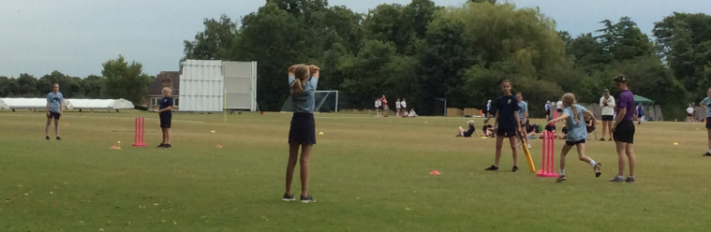
FAVSP Girls Cricket Competition
In the lead up to the event the recruitment again became of targeted recruitment. The Year 6 girls were targeted for all of the reasons previously mentioned and all of their hard work that had led up to this tournament. They were ready to compete as a group of 10 girls. They had grown into a team together and more than put in the necessary preparations. This was celebrated and communicated with their parents and the reasons for their selection also communicated and celebrated. I discussed with the girls the reasons for selection and we celebrated in our after-school cricket club. We focussed on the positivity of the journey that they had been on and mapped out how we were going to get competition ready. A Year 6 girls afterschool cricket club was set up so that we could further our preparations and ensure that each of the girls could work on the required set of skills, but also so they knew and understood their individual roles and how best to play them. We were lucky enough to have Cheshire Cricket come and help us with our preparations once more which gave the girls a huge amount of confidence in themselves and their abilities. I ensured that the girls could see clearly how we were planning on playing and organising our team. They knew that they could come and speak to me and they were leading the sessions with the things that they wanted to work on. The focus was on having fun and growing as a team prior to the tournament. It was about working together for each other and the positivity of what was to come regardless of the results.
During Competition
On the day of the competition we kept all of the messages consistent and positive. We talked about why we were there, what our motivations had been and about how far we had come throughout the process. The girls knew what their individual and team roles were and the importance of always trying their best. The support they received was always encouraging and offered the right level of advice. The girls took on board all of the messages and preparation and performed brilliantly winning the tournament.
Celebrating success
We celebrated immediately after the competition but kept the information given brief and consistent. The children were then able to celebrate their success with the class and the whole school in an assembly. The positives were the focus and how they had played and acted as individuals and as a team. The reflected on the positive and negatives of the tournament a day or two after the event. This reflection time was invaluable in helping them to see what they did well and how they can improve.
Further Preparations
After celebrating their success, the girls then had to refocus on the County Finals. We kept the messages consistent with what had come before, but brought in different people to reinforce those messages and offer different advice. During the Year 6 girls after school cricket club we had Mandy Dorrell attend one of the sessions and a previous teacher attend another. These new faces offering different advice was invaluable to the girls and how the continued their preparations.
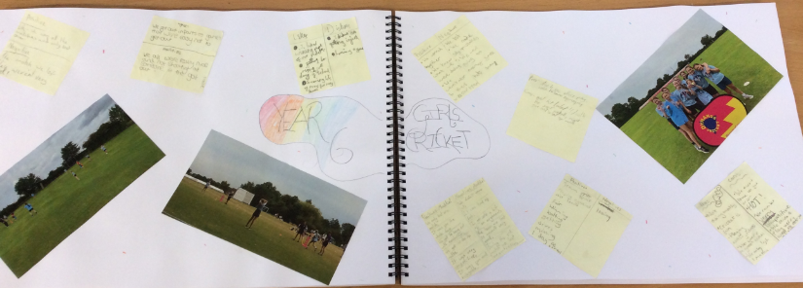
Summary
The positive experiences of competition have been so vast and have had such a great impact on this set of 10 Year 6 girls. These memories and moments will stay with them for their whole lives. Not necessarily because of the successes, but because of how they were achieved and how they brought the group together, helping them mature and work together. The girls didn’t win the County finals but competed brilliantly as a team. They supported each other when they lost and in the moments of loss all of the work that had led up to that moment came to fruition.

