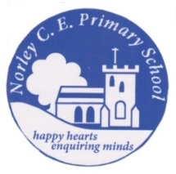
Celebrating our Achievements 2019
Phonics  Year 1 | Percentage achieving | National Average
 | 80% | 82%
EYFS | Percentage achieving a Good Level of Development | National Average | Average Total Points Score | National Average
 | 73% | 71.8% | 40.5 | 34.6

Key Stage 1 | Percentage achieving  Age Related Expectations | National Average | Percentage working at a greater depth | National Average
Reading | 87% | 75% | 27% | 25%
Writing | 86% | 69% | 13% | 15%
Maths | 80% | 76% | 27% | 22%
Key stage 2 | Average progress | Average Scaled score | Percentage achieving Age Related Expectations | National Average | Percentage working at a greater depth | National Average
Reading | 3.9 | 110  (104 NA) | 100% | 73% | 44% | 27%
Writing | -3.7 | N/A | 72% | 78% | 6% | 21%
Spelling, Grammar and Punctuation | N/A | 109  (106 NA) | 94% | 78% | 39% | 36%
Maths | -0.9 | 106  (105 NA) | 89% | 79% | 28% | 27%
Key stage 2 Attainment | 72% with National average 65%

